


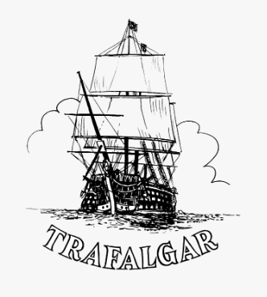



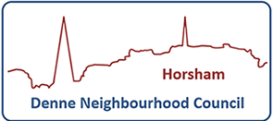

Denne, Trafalgar, and Forest Neighbourhood Councils

Neighbourhood Warden Report

February 2026

Patrols
During the month of February, we were on patrol in the community for a total of 106 hours 15 minutes.
February contained a Half Term and so we saw a rise in young people in town. Despite the weather, we did see young people and their families in town, and it was great to see families enjoying time off together.
February’s patrol time included 50 hours in Denne. We completed numerous joint patrols with the Police’s Horsham Town Team.
We spent 29 hours 30 minutes in Forest which included covering areas such as New Street and Bennetts Field.
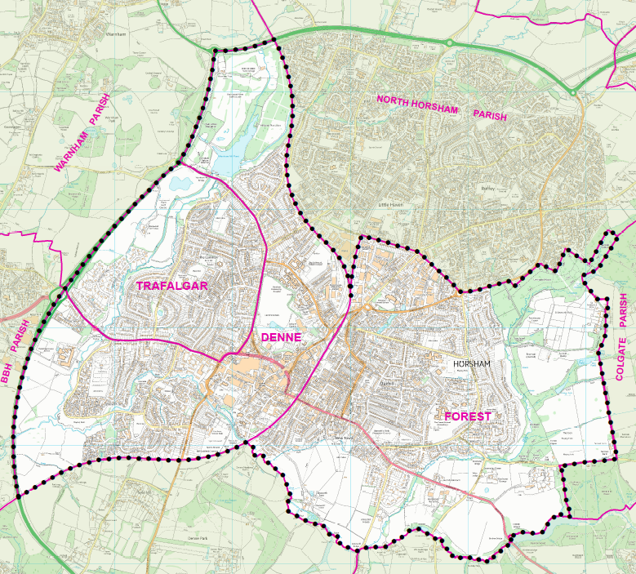
We spent 26 hours 45 minutes in Trafalgar this month. This included completing checks of the parks and green spaces.

One Year in Albery House!
February marks one year since we moved over into the office at Albery House and it’s great that the office is fully functioning and members of the public are aware of our ‘not so new’ base.

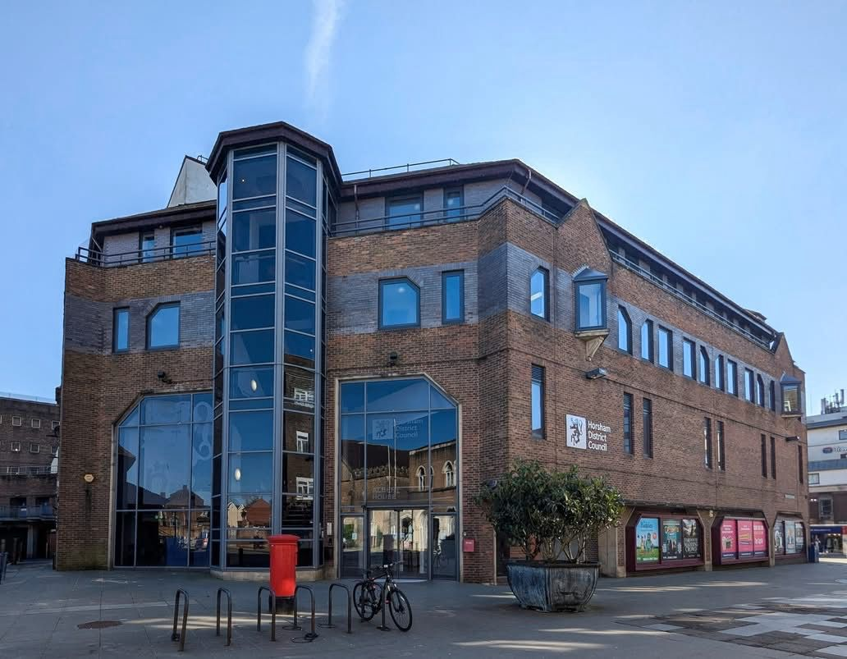

Community engagement/events/meetings
Community Support Networking Event:
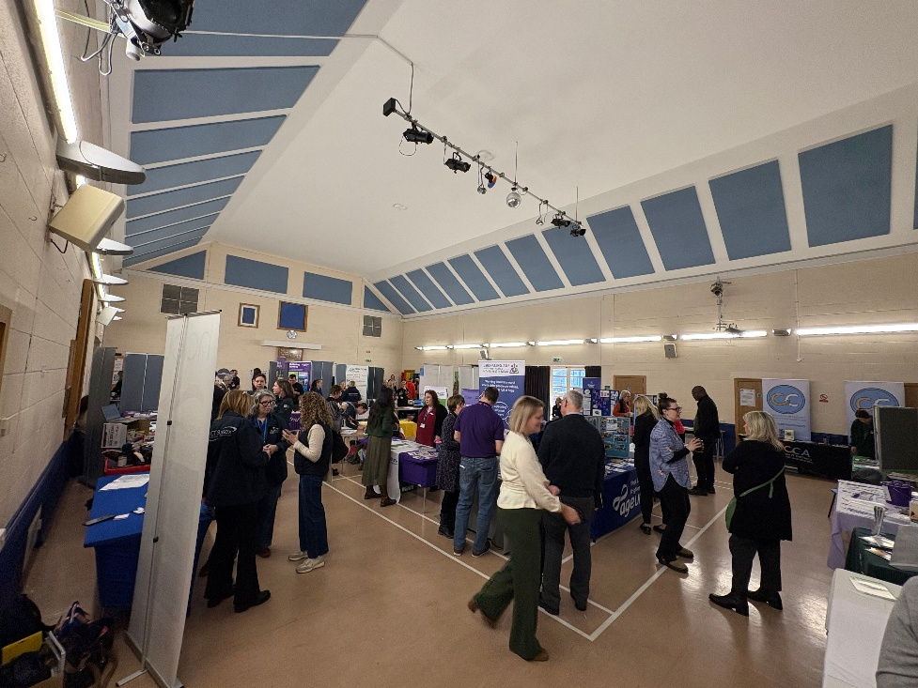
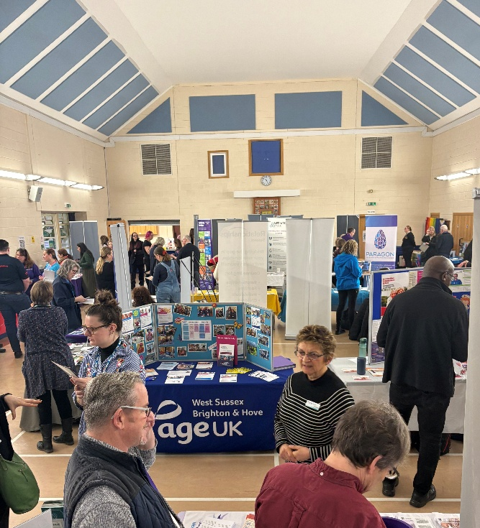
February saw an incredibly successful networking event take place in Ashington. It was great to contact new organisations and see how other organisations have changed over the year. We made some beneficial connections and will be linking in with new people over the year. These events are so helpful for organisations to network and learn how to serve the community together and even more effectively.

Dungeons & Dragons Club:

Our Dungeons & Dragons Club evenings, in partnership with 4TheYouth, is continuing in 2026. We have seen new young people joining each week and regulars returning. There is still space available for more young people to join this club. We have a had large increase of players recently and the club is successfully expanding.

Should you know a young person who wishes to attend this club, then please feel free to sign them up using the link below. We expect this to fill up fast, so please do not hesitate in getting your young person signed up! https://bookwhen.com/4theyouthltd


Horsham Market:

We continue to stay in close contact with Horsham Market and speak with the market stall holders. This month we have responded to the concerns of an assault. We encouraged all assault and theft to be reported to Sussex Police and informed the Neighbourhood Policing Team. Horsham Market is a wonderful hub of the community, and I would encourage anyone to attend on a Thursday, Friday, or Saturday.


West Sussex Fire and Rescue Service Safety Meeting:
We held our WSFRS Safety Meeting in Albery House. This gives us an opportunity to talk about buildings and places that potentially could be of concern.

We discussed fire safety doors at the Forum and their importance in holding back fires and saving lives. This was after we experienced some damage to several fire doors in the car parks, these doors are to be replaced as soon as possible.

We are planning a trip to the WSFRS Fire Station with some young people in March. This visit became fully booked incredibly quickly. For more information, please see our Facebook page and get in touch if you’d be interested in a potential future visit.

Finally, we discussed a few events which would benefit from a WSFRS presence. WSFRS also complete ‘Safe and Well’ visits to vulnerable people. If you know anyone who may benefit from this then please get in touch. More information on ‘Safe and Well’ visits can be found here: https://www.westsussex.gov.uk/fire-emergencies-and-crime/west-sussex-fire-and-rescue-service/home-fire-safety/safe-and-well-visit/

Sussex Police and Anti-Social Behaviour (ASB)
Sussex Police:

As a Neighbourhood Warden I have regularly patrolled with our Police Community Support Officers (PCSO’s) and continue to share Information with them. We have a dedicated ‘Town Team’ of three PCSO’s. During February, we had approximately 45 calls with the PCSO Town Team, and we completed 21 joint patrols.

If there any community events you believe would benefit from a visit from the Neighbourhood Wardens and / or PCSO’s then please get in touch, and this can be arranged.

Anti-social behaviour:

We have seen an increase in ASB in town over February. We suspect this is partly due to the half term. We continue to address anti-social behaviour as and when we come across it during our regular patrols and continue to team up with our colleagues at Sussex Police and complete joint patrols in the Denne, Forest, and Trafalgar Neighbourhoods.

We have shared relevant information with partner agencies to aid in the prevention and reduction of Anti-Social Behaviour (ASB) related incidents within the town centre. We have supported a few residents with advice and guidance for those having difficulties with their neighbours and community around them. We continue to encourage members of the public to report all incidents to Sussex Police’s website: - https://www.sussex.police.uk/ro/report/

For more information on how to report anti-social behaviour and the council’s role regarding anti-social behaviour, please visit the link below:

https://www.horsham.gov.uk/community/safety-and-emergencies/anti-social-behaviour

Cycling
This month we have asked 14 cyclists to dismount on West Street, 12 of these dismounted. 2 cyclists chose to continue to cycle.
Bike thefts are still prevalent, and members of the public can order their own anti-theft stickers from The Bike Register https://www.bikeregister.com/
Sussex Police have also shared information on how to secure your bike appropriately:
https://www.sussex.police.uk/cp/crime-prevention/keeping-vehicles-safe/how-safe-is-your-bike/


Older residents, vulnerable people, and youth engagement

Youth engagement:

February saw a normal rise in young people in town due to half term. It was lovely to see our local young people enjoying the town on their time off.

Sadly, we did see a rise in ASB this half term and we continue to engage with the regular young people out and about in Town centre and further afield. We often see the same young people and have slowly built a relationship with our known faces. They usually respond well to guidance and advice when it is needed, and we regularly link in with Sussex Police who can complete home-visits and meet parents when it is required.

Vulnerable residents:
In February, we have been in contact with eight members of our community who are potentially vulnerable. We continue to signpost to support and ensure that services are working with these residents.

Signposting:
We had 78 conversations described as ‘Signposting’ this month. This can be anything from our local foodbanks and community fridge to reporting abandoned trolleys. During our foot patrols we spend a lot of time discussing with residents the support and resources available to them. Please see our resource page for the services we regularly signpost to.

Safeguarding:

This month we did complete a safeguarding referral regarding an incident in town, and we leave this with WSCC to follow up and ensure appropriate actions are taken and measures are put in place.

