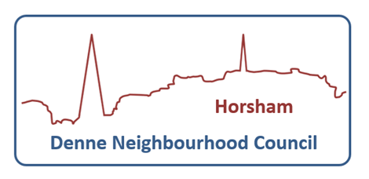 | Horsham Denne Neighbourhood Council  Register of Members’ Interests
Member's Full Name: Jane Vaughan
Date of Election / Co-option: 17th July 2025

Member’s Declaration

- I declare that the information given in this form is complete and correct
- I agree to give details of any changes to the information in this form within 28 days of becoming aware of the change.
- I agree to give notice within 28 days of any Disclosable Pecuniary Interest¹, not already on the register, which is made known at a meeting.
- I acknowledge that the information will be available for inspection at all reasonable hours and will be posted on the website of Horsham Denne Neighbourhood Council (HDNC).

Signed…………………………………………………… Dated ……25 July 2025………..

Please return this form in hard copy to: The HDNC Clerk:

Mrs S.J.Doy,
1 Rough Way, Horsham, RH12 4DE

If you have any questions about this form, please contact the Clerk who may contact the Monitoring Officer, Horsham District Council, email: standards@horsham.gov.uk.

Please note in relation to questions A to C you are required to provide details about both your interests and those of your partner.

Part A: Employment

Do you or your partner undertake any employment, office, trade, profession or vocation for profit or gain? Your partner means your spouse or civil partner; a person with whom you are living as husband or wife. If yes, please provide details.

No

Part B: Land
Do you or your partner have any beneficial interest in land (other than your home) which is within the area of HDNC? If yes, please give details.

No

Part C: Membership / Representation of other organisations

C1.1 Are you HDNC’s appointee or nominee on an outside body? If yes, what is the name of the outside body?
C1.2 Are you a member of, or in a position of control or management of any organisation (other than HDNC) exercising functions of a public nature? If yes, what is the name of the body and what is your position?
C1.3 Are you a member of, or in a position of control or management in, an organisation directed to charitable purposes? If yes, what is the name of the organisation and what is your position?

No

C2 Are you a member of, or in a position of control or management in, an organisation (including any political party) (i) whose principal purposes include the influence of public opinion or policy, (ii) which exercises public functions, and/or, (iii) which is directed to charitable purposes? If yes, what is the name of the organisation and what is your position?

I am a volunteer adviser with Horsham Citizens Advice.

C3 Are you a member of, or in a position of control or management in a professional association? If yes, what is the name of the association and what is your position?

No

C4 Do you have any unpaid directorships? If yes, please provide details. If no please read paragraph below on how to declare any gifts/hospitality you have received.

No

Gifts and hospitality

Have you received or refused a gift or hospitality with an estimated value of at least £50 from any person whose interests may be affected by any business of HDNC?
Delete as appropriate:

No

If yes, please complete the Members’ Notification of Receipt of Gift or Hospitality form (available from the Horsham District Council’s Monitoring Officer on request).

- Pecuniary Interests. Definitions:
https://assets.publishing.service.gov.uk/media/5a748e08ed915d0e8bf193c8/Openness_and_transparency_on_personal_interests.pdf

